Formed in 1965 to provide leisure activities for adults in Harrow with a learning disability

A monthly publication with
news of Tanglewood activities,
items of interest and views and
comment concerning people
living in Harrow with a learning
disability. Published since 1979
Edited by Geoff Havard

www.tanglewood.club geoff.havard@mail.com
Reg. Charity No. 1202404
ISSUE No. 519 DECEMBER 2024

Merry Christmas to all Tanglewood club members and to all our readers

At tonight’s club (Dec 2nd) we were having a Christmas Bingo – some of you will have won prizes!! NEXT WEEK
IT IS PANTO TIME
OH YES IT IS!!
The Panto this year is of Cinderella so make sure you are here, The normal £5 subs will apply but you will get FREE drinks. Please note however that although the Panto is scheduled to finish at 9.00 it might over-run slightly.
OUR CHRISTMAS PARTY ALSO IN THIS MAG.
Is on the 16th Lauren Jones and her Rock 100 club results p 2 / All our yesterdays p 4
‘N’ Roll band with provide the music and Wii game comp. – p. 3 / Carers page - p.5
CLUB WILL RUN ‘TILL 10.00 Football prediction Christmas update
It’s a FREE night with lots of Food and drink Lots of word searches for you to do
THE FIRST CLUB OF THE NEW YEAR WILL BE JANUARY 6th
Tanglewood magazine Dec 2024
2
100 CLUB

THE RESULT OF THE NOVEMBER 100 CLUB DRAW,
THE 502nd, WAS AS FOLLOWS:-

FIRST PRIZE OF £250 - TICKET No. 62 = Isobelle Bradley

SECOND PRIZE OF £125 - TICKET No. 39 = Christina Herbert

THIRD PRIZE OF £62.50 - TICKET No. 9 = Vic Sanders

FOURTH PRIZE OF £31.25 - TICKET No. 19 = Roger Sheehy

The winning numbers were drawn by – Robert Ward

No. 62 = This is the 13th time that this number has been drawn winning £1,400 for it’s owners.
Isobelle is club member Matthew Blennerhassett’s sister-in-law, she took on this number in May 2021 She has won nothing in the 43 draws that have taken place since then – until last Monday then, exactly 100 months since it last made an appearance (June 2016) it gets drawn out for the first prize. Well done Iszi, you deserve it girl.

No. 39 = This is the 18th time that this number has been drawn winning £1,831.25 for it’s owners.
This number is owned by former club helper Christina – she won £31.25 just two months ago and this £125 takes her total winnings to £1,311.25 Her 11 wins have been 4 first’s, 4 seconds, 21 third’s and one fourth. Well done Chris – another thoroughly deserved winner. Get well soon Chris.

No. 09 = This is the 17th time that this number has been drawn winning £1,472.50 for it’s owners.

Club helper Vic has held this number since July 1994. This is his 12th win, 7 of them have been a third prize making his total winnings £1,072.75 from an outlay of £1,900
It was last drawn in March 2022.

No. 19 = This is the 19th time that this number has been drawn winning £1,603.75 for it’s owners. Former club helper Roger took on this number in Feb. 1996 and this is his 15th win, the last being in Sep. 2023. His total winnings are now £1,313.75

Tanglewood Magazine Dec 2024
3
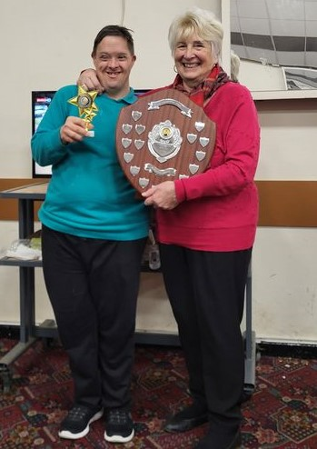
Wii GAME COMPETITION
This was our first Wii game competition since 2019. A total of 22 club members took part and, because of the scoring method we use, it takes several months to complete the 7 rounds – Here are all the scores from all 6 rounds:-
ROUND ONE top 16 go through ROUND TWO ROUND THREE
01 Simon Parsons 225 Top 12 go through Top 8 Go through
02 Debbie Brice 215 01 Paul Havard 237* 01 Chris Gridley 219
03 Scott Irons 213 02 Scott Irons 235 02 Syed Amin 202
04 Kevin Sweeney 206 03 Kevin Sweeney 214 03 Paul Havard 189
05 Syed Amin 202 04 Syed Amin 181 04 Kevin Sweeney 185
06 Paul Havard 177 04 Usha Myanger 181 05 Simon Parsons 172
07 Chris Gridley 172 06 Chris Gridley 178 06 Scott Irons 170
08 Nikesh Shah 169 07 Nikesh Shah 176 07 Robert Ward 143
09 Mohamed Abdulla 163 08 Simon Parsons 173 08 Usha Myanger 140
10 Umair Aslam 158 09 Debbie Brice 172 09 Debbie Brice 139
11 Natalie Killestein 157 10 Emma Wilkinson164 09 Nikesh Shah 139
12 Emma Wilkinson 150 11 Robert Ward 155 11 Karen Havard 136
13 Robert Ward 144 12 Karen Havard 151 12 Emma Wilkinson 131
14 Kaviths Tarcisius 136 13 Mohamed Abdulla 149
15 Usha Myanger 127 14 Natalie Killestein 132 ROUND FOUR Top 6 go through
16 Karen Havard 125 15 Umair Aslam 98 01 Paul Havard 204

17 Kenji O’Connor 122 16 Kavitha Tarcisius 79 02 Scott Irons 193

18 Ben Cann 119 03 Simon Parsons 179
19 Michael Bird 117 04 Syed Amin 173
20 Matthew Blenner’ett 91 05 Chris Gridley 169
20 Mark Bucke 91 06 Kevin Sweeney 167
22 Karen Elvins 90 07 Usha Myanger 133
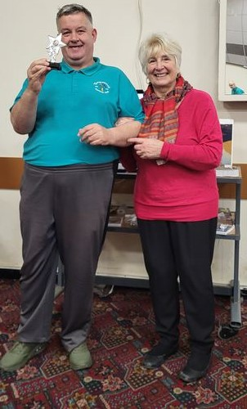
08 Robert Ward 130

ROUND 6 - SEMI FINAL
ROUND FIVE Top 4 go through 01 Kevin Sweeney 202
01 Paul Havard 224 02 Paul Havard 192
02 Kevin Sweeney 199 02 Syed Amin 192
03 Syed Amin 191 04 Simon Parsons 181
04 Simon Parsons 188 (SEMI-FINAL PLAY-OFF)
05 Chris Gridley 175 Paul Havard 191 – 170 Syed Amin
06 Scott Irons 147
BEST OF THREE FINAL
01 Paul Havard 187 - 185 Kevin Sweeney
02 Paul Havard 183 - 148 Kevin Sweeney
TORNAMENT ORGANISER - JANE BALLARD

We waited a long time for this Final – five years in fact – but it is a very popular tournament which most of our club members can enter. This was the tenth Wii game competition and Paul has appeared in 7 finals winning 4 (including this one). This was only Kevin’s 2nd final having lost to the same opponent in 2016 – these two have dominated the Tanglewood sports competitions since the 1990’s Kevin has appeared in 32 finals and Paul 29. Our special guest for the evening was the lovely Maureen Davis – she is pictured presenting the trophies to the to finalist’s – Paul keeps the “Christopher Davis Memorial Shield” for 12 months – named after Maureen’s son who was a Tanglewood club member until his untimely death in 2011. Chris loved this Wii bowling game so it’s fitting that we name the tournament in his memory.
Tanglewood Magazine Dec 2024
4
ALL OUR YESTERDAYS
Regular feature
TANGLEWOOD 10 YEARS AGO – Dec. 2014 = I won the helpers darts competition beating Rupi Witts in the final and John Pearse won the Pool competition beating Kevin Sweeney in the final. Our annual report shows a total expenditure of £17,280 and Income of £23,239 and there was £16,o82 in the bank. The total number of registered club members was 76 (43 male & 33 female) with an average age of 49 Ed – Today we have 47 members with an average age of 52

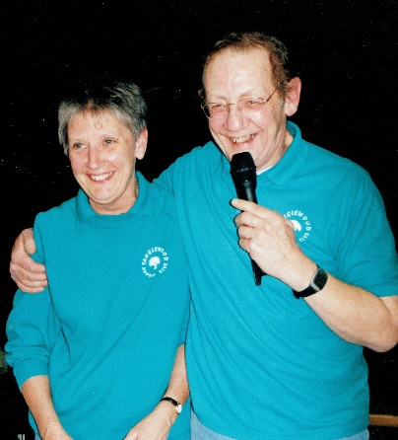
TANGLEWOOD 20 YEARS AGO – Dec. 2004 = Sue Flewers, who had been a club helper for over 15 years attended her last club on Nov. 15th. Before moving to Wales. She is pictured with me on her last night. Sue was a great loss to us but I’m pleased to say she still keeps in touch. Kevin Sweeney won the Pool singles title for the 6th time, beating Simon Parsons in the final. Our Annual Report shows a total expenditure of £11,292 and a total income of £9,732 and we had £6,621 in the bank.

IN THE POP CHARTS
Christmas No. 1 = 25 years ago - “I Have a Dream” Westlife
Christmas No. 1 =50 years ago = “Lonely This Christmas” - Mud

NATIONAL & INTERNATIONAL
25 YEARS AGO - Dec. 1999 = The UK government devolves power in Northern Ireland to the Northern Ireland Executive. / NASA loses contact with the Mars Polar Lander, costing $165m plus $110m development plus $45m launch costs, smashes into the Mars surface after the engine cut out too soon. / Russian President Boris Yeltsin resigns leaving the P.M. Vladimir Putin as acting President. / As the whole world slowly moves towards a brand new millennium, there some concern that all the worlds computers will stop working because they wont understand the date not beginning with 19

50 YEARS AGO – Dec. 1974 = After leaving a pile of clothes on a beach in Miami in an attempt to make it look like he had drowned on Nov. 20th, was arrested in Melbourne Australia on 24th Dec (He was eventually imprisoned for 7 years for Fraud. However, he was released in 1979 on health grounds after suffering 3 heart attacks. He died in 1988 in a TV studio whilst recording a programme about missing people). The rate of inflation has reached 20% with petrol now costing 72p per gallon!!! / Greece votes to abolish the monarchy and become a republic. /

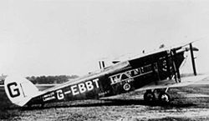
100 YEARS – Dec. 1924 = Adolf Hitler gets parole after serving just 8 months of a 5-year prison sentence for High Treason. / On Christmas Eve a De-Havilland DH-34 aircraft operated by Imperial Airways, en route to Paris crashed shortly after taking off from the airfield in Croydon killing all 8 people on board. This was the UK’s worst air crash and the first by Imperial Airways. The subsequent enquiry cleared the pilot of any blame stating it was an unknown mechanical defect.

Tanglewood Magazine Dec 2024
5
TANGLEWOOD GARMENTS
As you will see from our front page, we have changed our Logo to reflect our Diamond Jubilee year. We have also changed our official Colour from Emerald Green to Kelly Green. All Tanglewood club members have been offered a new T-shirt, Polo shirt, Sweat shirt, Baseball cap and Zipped hooded jacket. Thanks to a very generous donation, the six items worth £80 are being offered to club members absolutely free of charge.
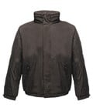
However, if anyone else wants any of the items shown below just let me know and I will order them for you (the costs is shown) Please don’t delay because I will be placing the order in before Christmas and it will be too late after the order has gone through. It may be sometime before I can put in another order.
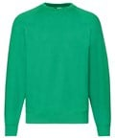
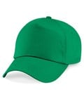

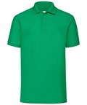

L to R T-shirt = white with large Logo / Polo shirt green with Breast Logo
Sweat shirt – green with breast logo / cap – green with logo . Jacket – rainproof
and windproof – black with Breast logo
The sizes are = S,M,L,XL,2XL, 3XL (The baseball cap is one-size)
CARER’S PAGE
Costs are T-shirt = £6.50 Email your order & pay by BACS
Polo shirt = £10.00 Tanglewood Club
Sweat shirt = £14.50 30 15 93
Baseball cap = £13.00 00056610
Jacket = £36.00
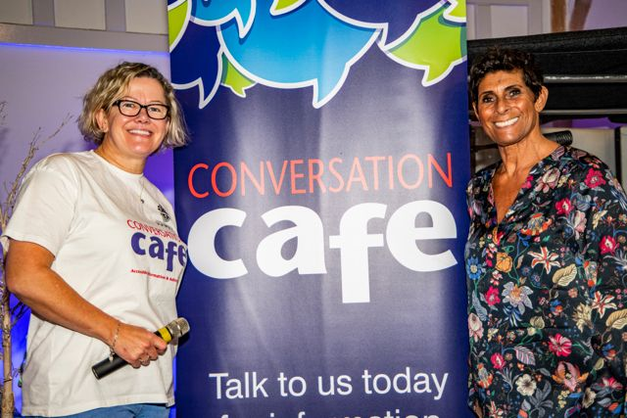
Allie Brice is Harrow Council’s Resident Engagement and Co Production Officer, Conversation Café Lead & Carers Champion. and is very keen to hear from Harrow residents who are unpaid carers or have disabilities. If you are interested in taking part in discussions, meetings & workshops focused on unpaid carers and people with disabilities, please contact her on allie.brice@harrow.gov.uk

Allie is pictured above with former champion Javelin thrower Fatima Whitbread. (in 1986 Fatima became the first5 British Athlete to set a world record in an athletic throwing event- throwing the Javelin 77.44 m. She won a gold medal in the 1987 Word Championships and a Silver in the 1988 Olympics).
Allie also runs the excellent “Conversation Café’s” which are held every Tuesday 10.00 a.m. – 2.00 pm at St Peter’s church West Harrow*, The Red Brick Café in Wealdstone 10.30a.m. – 1.30 p.m. every Thursday and the North Harrow Community Library 429, Pinner Road 2.00 p.m. – 4 p.m. every Wednesday. They are very welcoming and safe drop-in sessions where you can chat face to face with staff from Harrow Council and community partners Find out more = www.harrow.gov.uk/conversationcafe *= Please note that there will be no conversation café’s between 17th December and the 7th January. You can always contact Harrow Carer’s on www.harrowcarers.org

I INTEND TO INCLUDE A CARERS PAGE IN OUR MAGAZINE FROM NOW ON
Tanglewood Magazine Dec 2024
6

Tanglewood Magazine Dec 2024
7
Tanglewood Magazine Dec 2024
8
Tanglewood Magazine Dec 2024
9

NEXT MONTHS MAG. Will be published on Monday 2nd December
.
Tanglewood Magazine is published & printed by Tanglewood and written & edited by Geoff Havard M.B.E. © 2024
453, Northolt Road, South Harrow, Middx. HA2 8JH Tel: 020 8422 7781. (m 07799195556)

